**Overview of SDG 12: Responsible Consumption and Production**

Sustainable Development Goal (SDG) 12, titled "Responsible Consumption and Production," aims to ensure sustainable consumption and production patterns. It addresses the need to reduce the negative impacts of human activities on the environment and human health while promoting economic growth. The goal is to improve resource efficiency, minimize waste, and encourage sustainable practices throughout the lifecycle of products and services.

**Key Aspects of SDG 12:**

1. **Resource Efficiency:** Promote the efficient use of resources such as water, energy, and raw materials to reduce environmental impact and optimize resource use.
2. **Sustainable Practices:** Encourage businesses, governments, and individuals to adopt sustainable practices that reduce environmental footprints, including sustainable production processes and sustainable agricultural practices.
3. **Waste Reduction:** Minimize waste generation through practices like recycling, reusing, and reducing consumption. This involves better waste management systems and technologies.
4. **Product Lifecycle Management:** Ensure that products are designed for longevity, reuse, and recycling. This involves incorporating environmental considerations into product design and production processes.
5. **Consumer Awareness:** Increase awareness and educate consumers about the environmental impacts of their consumption choices and encourage more sustainable lifestyles.
6. **Support for Developing Countries:** Assist developing countries in transitioning to more sustainable consumption and production patterns through technical and financial support.

**SDG 12 Alignment with Broader Goals:**

1. **Environmental Protection:** Aligns with environmental sustainability by reducing pollution, conserving resources, and minimizing waste, contributing to goals such as clean water (SDG 6) and climate action (SDG 13).
2. **Economic Development:** Supports sustainable economic growth by promoting efficient resource use, which can lead to cost savings and new business opportunities.
3. **Health and Well-being:** Reducing pollution and waste contributes to better health outcomes, aligning with goals related to health and well-being (SDG 3).
4. **Equity and Justice:** Encourages fair and equitable access to resources and promotes responsible production practices that can support social equity and justice.
5. **Innovation and Infrastructure:** Drives innovation in sustainable technologies and infrastructure, supporting SDG 9 (Industry, Innovation, and Infrastructure) through advancements in green technologies and sustainable production methods.

**Key Targets of SDG 12:**

* **12.1:** Implement the 10-Year Framework of Programs on Sustainable Consumption and Production Patterns, with all countries taking action.
* **12.2:** Achieve the sustainable management and efficient use of natural resources.
* **12.3:** Halve per capita global food waste at the retailer and consumer levels and reduce food losses along production and supply chains.
* **12.4:** Achieve environmentally sound management of chemicals and all wastes throughout their life cycle.
* **12.5:** Substantially reduce waste generation through prevention, reduction, recycling, and reuse.
* **12.6:** Encourage companies to adopt sustainable practices and to integrate sustainability information into their reporting cycle.
* **12.7:** Promote public procurement practices that are sustainable, in accordance with national policies and priorities.
* **12.8:** Ensure that people everywhere have the relevant information and awareness for sustainable development and lifestyles in harmony with nature.

**Problem Definition and Significance of SDG 12: Responsible Consumption and Production**

**Problem Definition:**

SDG 12 addresses critical issues related to unsustainable consumption and production patterns, which have far-reaching environmental, economic, and social consequences. The key problems include:

1. **Resource Depletion:** Overuse of natural resources such as water, minerals, and fossil fuels is leading to their rapid depletion. This not only threatens future availability but also contributes to ecological imbalance and resource scarcity.
2. **Environmental Pollution:** Industrial processes, agricultural activities, and consumer goods contribute to pollution, including greenhouse gas emissions, hazardous waste, and plastic pollution. These pollutants adversely impact air, water, and soil quality.
3. **Waste Generation:** High levels of waste are generated across production and consumption stages, with significant amounts ending up in landfills or the environment. Many products are not designed for recycling or reuse, exacerbating waste management challenges.
4. **Inefficient Resource Use:** Inefficiencies in resource use lead to higher costs and environmental impacts. For instance, energy and water are often consumed disproportionately in various sectors, contributing to unsustainable practices.
5. **Lack of Awareness:** Consumers and businesses may lack awareness about the environmental impacts of their choices and practices, leading to continued unsustainable consumption patterns and insufficient demand for sustainable products.
6. **Inequities in Resource Distribution:** Developing countries often face challenges in adopting sustainable practices due to lack of resources, technology, and infrastructure. This can exacerbate inequalities and hinder their ability to achieve sustainable development.

**Significance of SDG 12:**

1. **Environmental Protection:** Addressing the problems associated with unsustainable consumption and production is crucial for protecting ecosystems and biodiversity. Reducing pollution and conserving resources directly contribute to environmental sustainability and the health of the planet.
2. **Climate Action:** Efficient resource use and waste reduction are integral to mitigating climate change. Lowering greenhouse gas emissions and minimizing waste can help limit global warming and its associated impacts.
3. **Economic Benefits:** Improving resource efficiency can lead to cost savings, enhance business competitiveness, and stimulate innovation. Sustainable practices can also open new markets and business opportunities in green technologies and services.
4. **Health and Well-being:** Reducing pollution and waste has direct health benefits, including cleaner air and water, and reduced exposure to harmful chemicals. This aligns with broader health goals and improves quality of life.
5. **Social Equity:** Promoting sustainable consumption and production can address disparities in resource access and distribution. Supporting developing countries in adopting sustainable practices helps achieve social equity and inclusion.
6. **Future Generations:** Sustainable consumption and production patterns ensure that resources are available for future generations, allowing them to meet their needs without compromising the ability of future generations to meet their own.

**Part 2: Database Design.**

**ERD (Entity-Relationship Diagram)**

Entities:

1. **Household**
   * Household_ID (Primary Key)
   * Household_Name
   * Address
2. **Food_Item**
   * Food_Item_ID (Primary Key)
   * Name
   * Category
   * Expiration_Date
3. **Food_Waste**
   * Waste_ID (Primary Key)
   * Household_ID (Foreign Key)
   * Food_Item_ID (Foreign Key)
   * Waste_Date
   * Quantity_Wasted

**Relationships:**

* A Household can have multiple Food_Waste records.
* A Food_Item can be associated with multiple Food_Waste records.

Schema: Check shared mysql scripts.

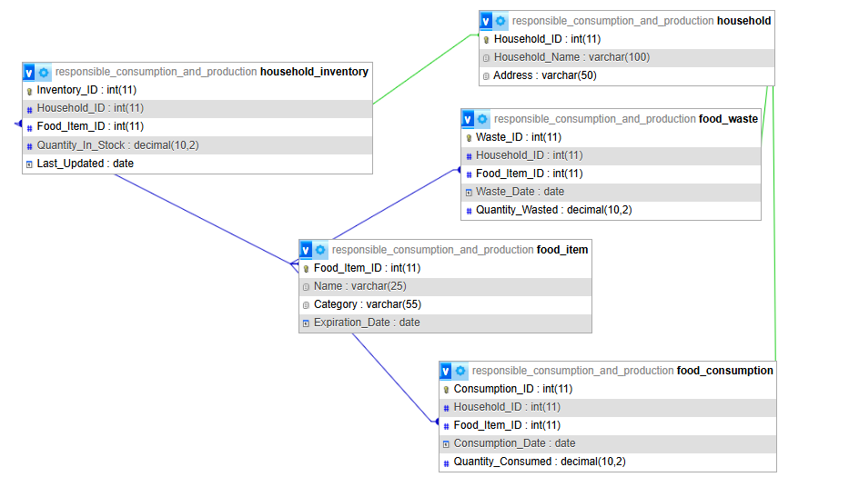

**Part 4: Data Analysis Using Excel**

**Importing Data from database to excel sheet.**

1. **Using MySQL Workbench**

MySQL Workbench provides a graphical interface for exporting data:

1. **Open MySQL Workbench** and connect to your MySQL server.
2. Go to **Server** > **Data Export**.
3. **Select the database** you want to export from the list on the left.
4. **Choose the tables** you want to export. You can select all or specific ones.
5. Choose the **export options** (e.g., export to a self-contained file or dump into a project folder).
6. Click **Start Export** to generate the SQL dump file.
7. **Using phpMyAdmin**
8. **Log in to phpMyAdmin** and select the database you want to export.
9. Click on the **Export** tab.
10. Choose the **export method**: "Quick" for a basic export or "Custom" for more options.
11. Select the **format** for the export (e.g., SQL, CSV).
12. Click **Go** to download the exported file.
13. **Using a MySQL Client**
14. **Open the MySQL client** and connect to your database.
15. Look for options related to data export or backup.
16. Select the database and tables you wish to export.
17. Configure the export settings and initiate the export process.

**Excel Data Analysis:**

**A. Creating Pivot Tables**

1. **Select Data:**
   * Click anywhere in the data range or table.
2. **Insert Pivot Table:**
   * Go to the **Insert** tab on the Ribbon.
   * Click **PivotTable**.
   * Choose to place the PivotTable in a new worksheet or an existing one, then click **OK**.
3. **Configure Pivot Table:**
   * Drag and drop fields from the field list into the **Rows**, **Columns**, and **Values** areas to create the desired summary.
   * Use the **Filters** area to add slicers if needed for interactive filtering.

**B. Creating Charts**

1. **Select Data:**
   * Highlight the range of data you want to chart.
2. **Insert Chart:**
   * Go to the **Insert** tab on the Ribbon.
   * Choose the desired chart type (e.g., Column, Bar, Line, Pie).
3. **Customize Chart:**
   * Use the **Chart Tools** on the Ribbon to customize the chart (e.g., change colors, add titles, format axes).

**C. Use Conditional Formatting**

1. **Select Data:**
   * Highlight the data range where you want to apply conditional formatting.
2. **Apply Formatting:**
   * Go to the **Home** tab on the Ribbon.
   * Click **Conditional Formatting**.
   * Choose a formatting rule (e.g., Data Bars, Color Scales) and configure it as needed.

**3. Create an Interactive Excel Dashboard**

1. **Design Your Dashboard Layout:**
   * Plan the layout of your dashboard (e.g., summary metrics, charts, and pivot tables).
2. **Create Summary Metrics:**
   * Use formulas like SUM, AVERAGE, COUNTIF, etc., to calculate key metrics.
   * Place these metrics prominently on your dashboard.
3. **Add Pivot Tables and Charts:**
   * Insert the previously created pivot tables and charts into the dashboard layout.
   * Ensure they are linked to your data and update dynamically.
4. **Add Slicers and Timelines:**
   * Click on a PivotTable or PivotChart.
   * Go to the **PivotTable Analyze** tab and click **Insert Slicer** or **Insert Timeline** to add interactive filters.
   * Place the slicers/timelines on the dashboard to allow users to filter data interactively.
5. **Design and Format:**
   * Adjust the colors, fonts, and layout to make the dashboard visually appealing.
   * Ensure that all elements are aligned and clearly labeled.

**Testing:**

**Test Data Integration:**

1. **Refresh Data:**
   * Manually refresh your data in Excel to ensure the updates are correctly reflected.
   * Go to the **Data** tab and click **Refresh All**.
2. **Check Dashboard Functionality:**
   * Interact with your dashboard’s slicers, filters, and charts to ensure they work as expected.
   * Verify that all elements update correctly and provide accurate insights.
3. **Validate Formulas and Calculations:**
   * Double-check formulas used in your metrics and pivot tables to ensure they are correct.
   * Test edge cases to confirm that calculations handle different scenarios properly.
4. **Perform User Testing:**
   * If possible, have others test the dashboard to provide feedback on usability and functionality.
   * Make adjustments based on feedback to improve the user experience.

**SQL queries to analyze data(Screenshot shared).**

1. **Retrieve All Food Waste Records.**

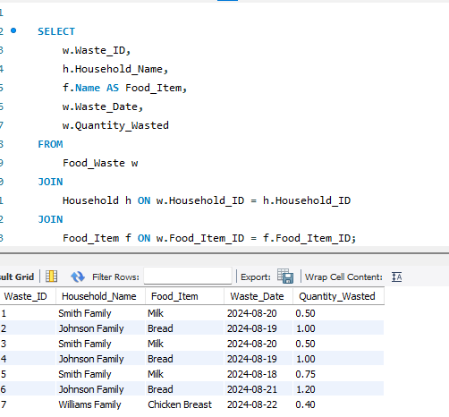

1. **Retrieve Food Waste for a Specific Household.**

This query retrieves all food waste records for a specific household (e.g., Household_ID = 1).

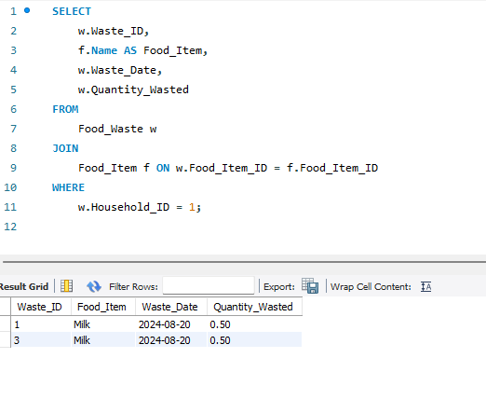

1. **Retrieve Food Waste by Food Item**

This query shows the total quantity of each food item wasted across all households.

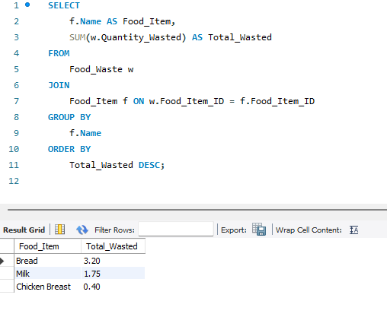

1. **Retrieve Food Consumption Records**

This query retrieves all records from the Food_Consumption table.

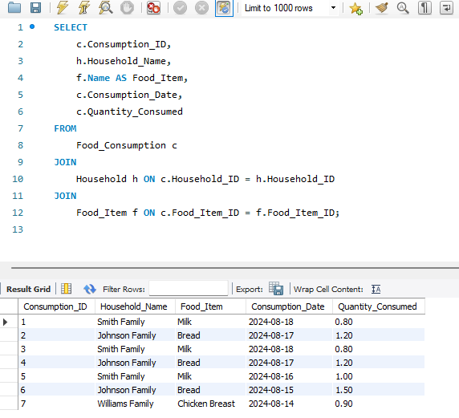

1. **Retrieve Inventory Levels**

This query retrieves the current inventory levels of food items in each household.

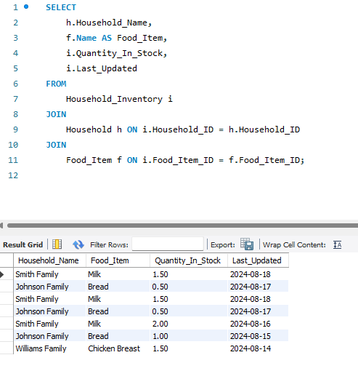

**Data Analysis in SQL.**

1. **Total Food Waste by Household**

This query shows the total quantity of food wasted by each household.

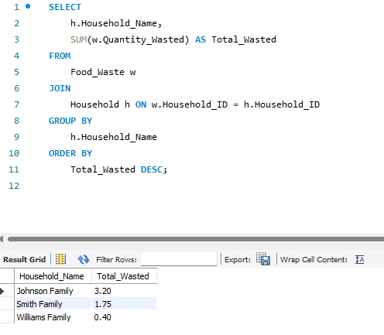

1. **Average Quantity of Food Wasted Per Household**

This query calculates the average quantity of food wasted per household.

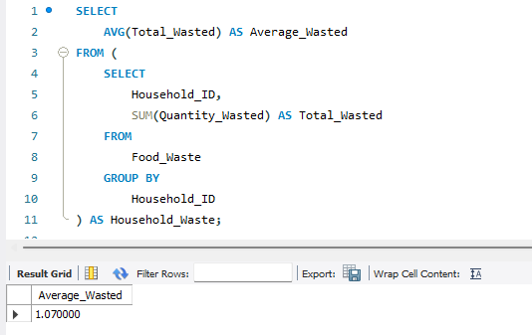

1. **Food Waste vs. Consumption**

This query compares the total quantity of each food item consumed versus wasted.

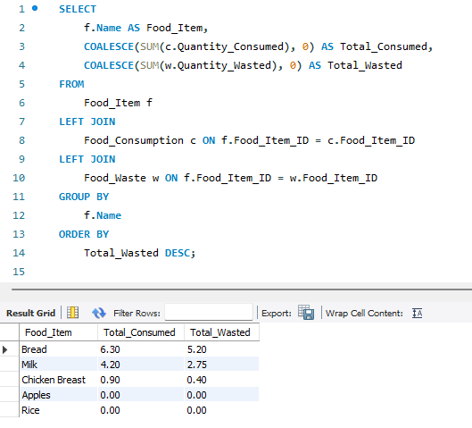

1. **Households with Food Items Close to Expiration**

This query retrieves households with food items that are close to their expiration date (e.g., within the next 7 days).

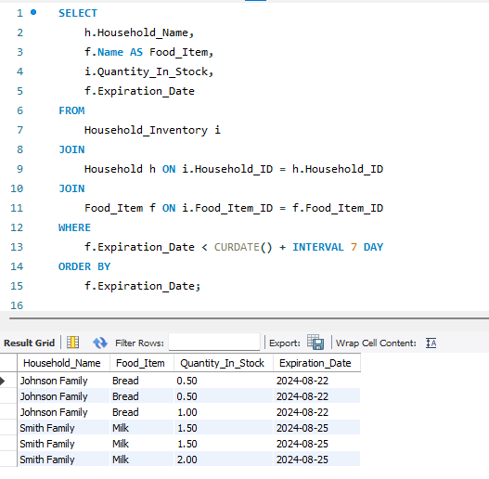

1. **Correlation Between Inventory Levels and Food Waste**

This query analyzes the relationship between inventory levels and food waste.

